**RAILWAY RESERVATION SYSTEM**

**Use Case Diagram :- Railway Reservation**

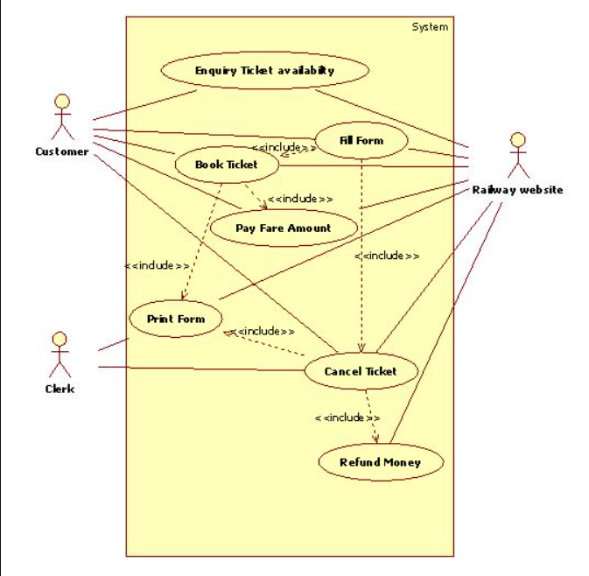

**ACTIVITY DIAGRAM FOR BOOKING TICKET:**

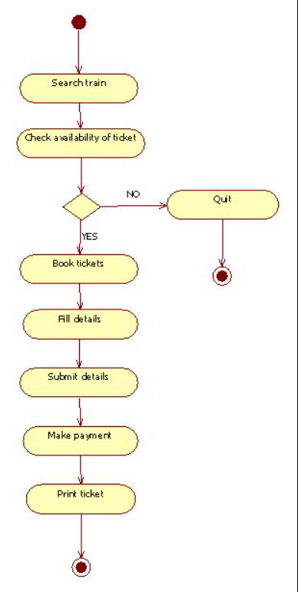

**ACTIVITY DIAGRAM FOR CANCEL TICKE**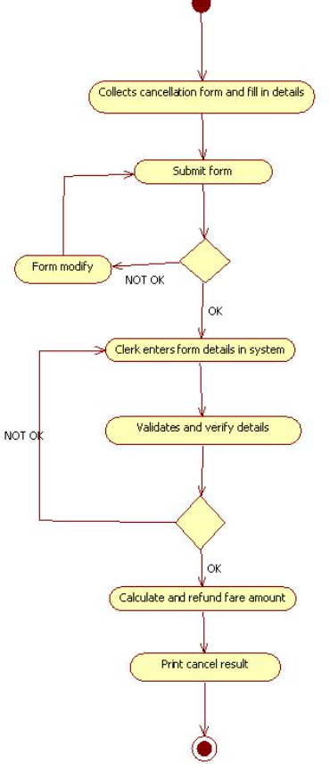

**CLASS DIAGRAM FOR RAILWAY RESERVATION SYSTEM:**

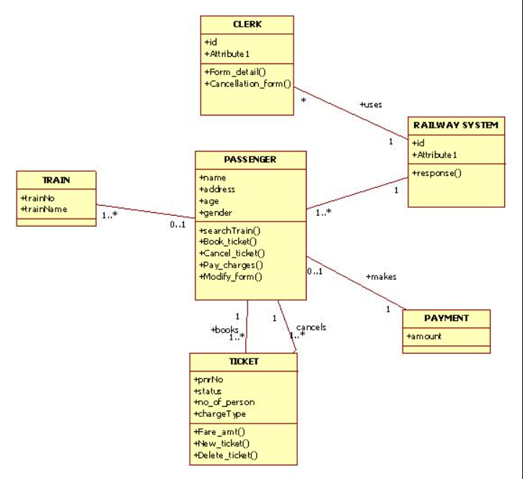

**COLLABORATION DIAGRAM FOR BOOKING TICKET**

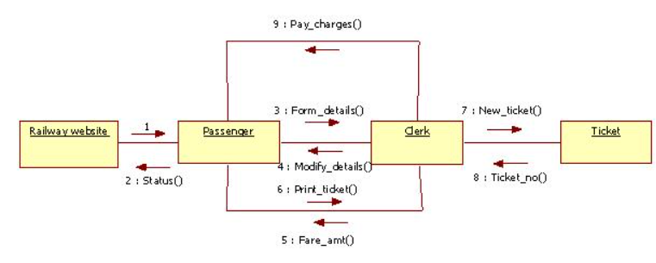

**COLLABORATION DIAGRAM FOR CANCEL TICKET:**

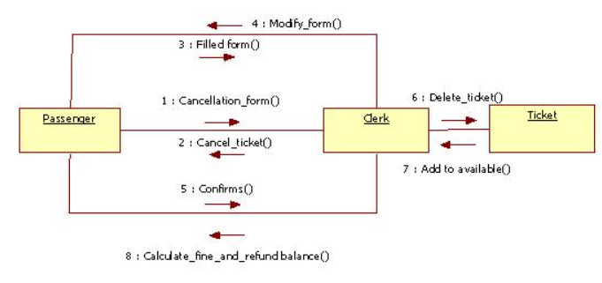

**SEQUENCE DIAGRAM FOR BOOKING TICKET:**

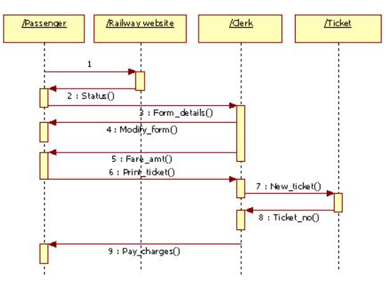

**SEQUENCE DIAGRAM FOR CANCEL TICKET:  
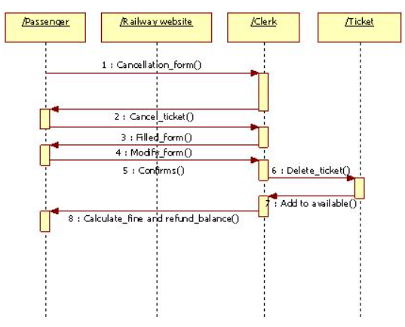**

**DEPLOYMENT DIAGRAM FOR RAILWAY RESERVATION SYSTEM:**

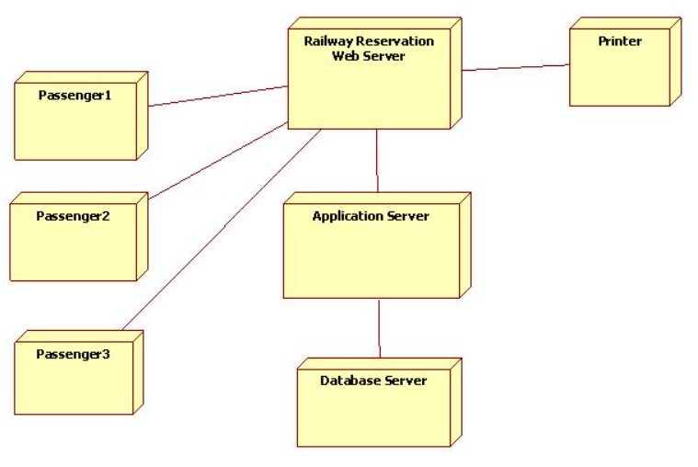

**COMPONENT DIAGRAM FOR RAILWAY RESERVATION SYSTEM :**

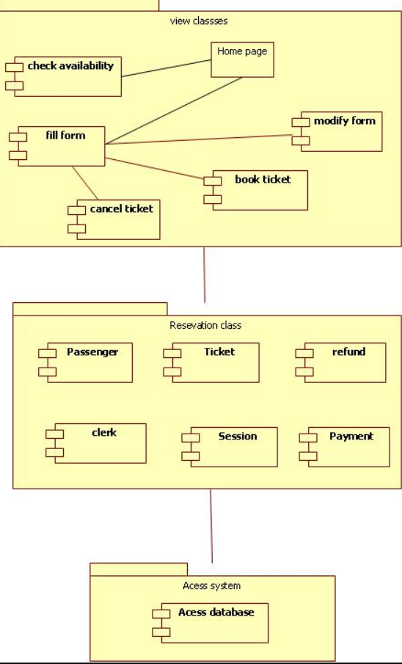

**State chart**

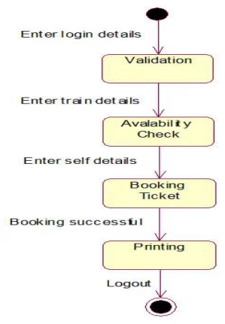

**ATM Case Study**

**1 .Use Case Diagram for ATM System, with use case specification.**

Step1: First an Actor is Created and named as User/Customer. Step2: Secondly a system is created for ATM.

Step3: A use case Enter PIN, Withdraw money is created and connected with user as association relationship.

Step4: Similarly various use cases like Deposit money, Balance Enquiry, Manage Account etc are created and appropriate relationships are associated with each of them.

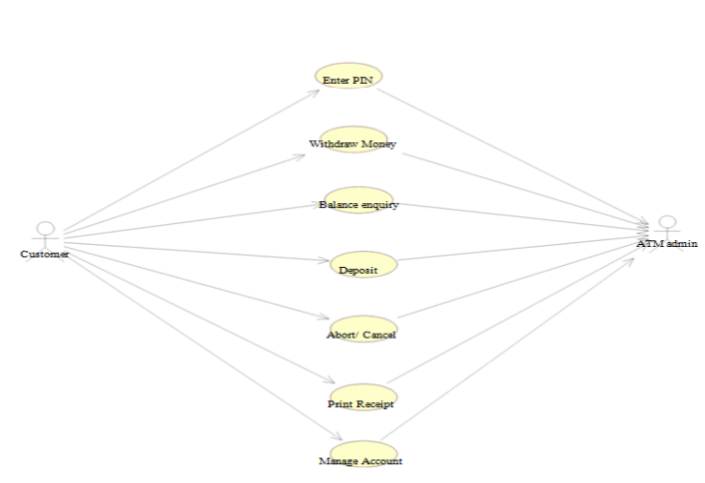

**2. Identify the classes for the ATM system and draw the Class Diagram**

Step1: First Classes are created.

Step2: Named as PinValid, Account Type, Transaction, Update, Server, Customer classes are created.

Step3: Appropriate relationships are provided between them as association.

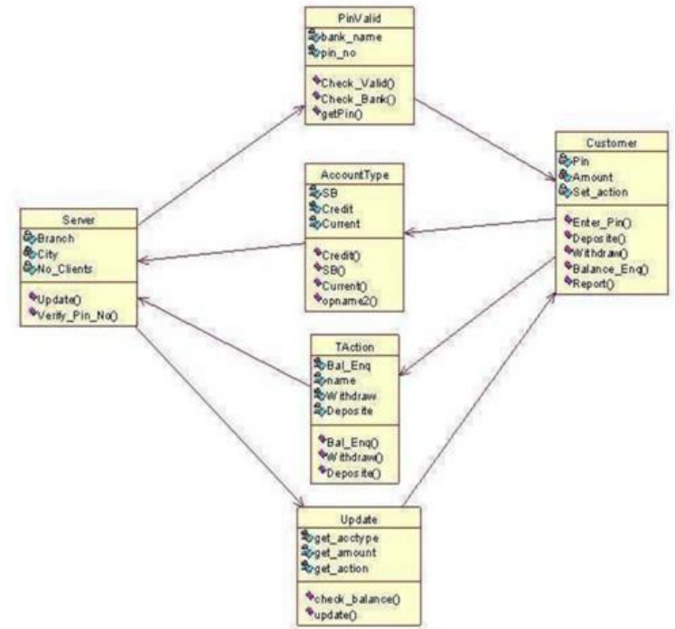

**3. Draw the Sequence for each of the use cases Identified.**

Step1: First An actor is created and named as user.

Step2: Secondly an object is created for Atm.

Step3: Timelines and lifelines are created automatically for them.

Step4: In sequence diagram interaction is done through time ordering of messages. So appropriate messages are passed between user and ATM is as shown in the figure.

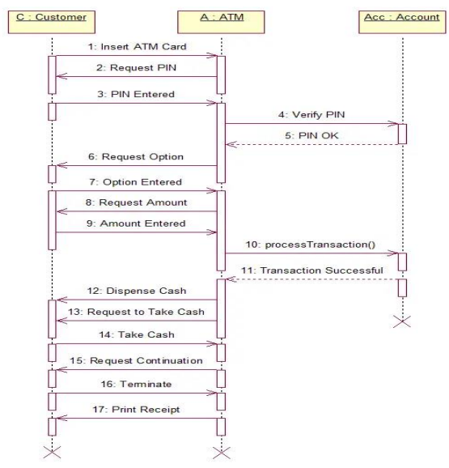

**Collaboration diagram:**

Step1: First an actor is created and named as user.

Step2: Secondly an object is created for ATM.

Step3: In collaboration diagram interaction is done through organization.

Step4: So appropriate messages are passed between user and ATM as shown in the figure.

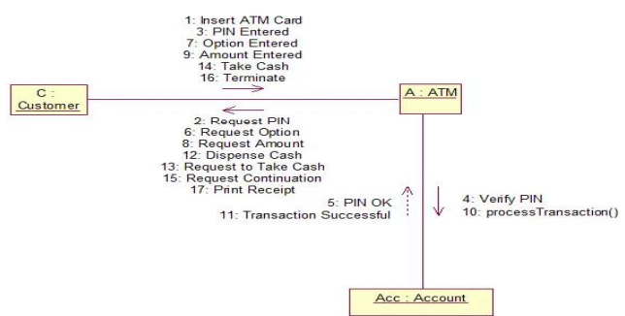

**Draw the State chat Diagram for the system.**

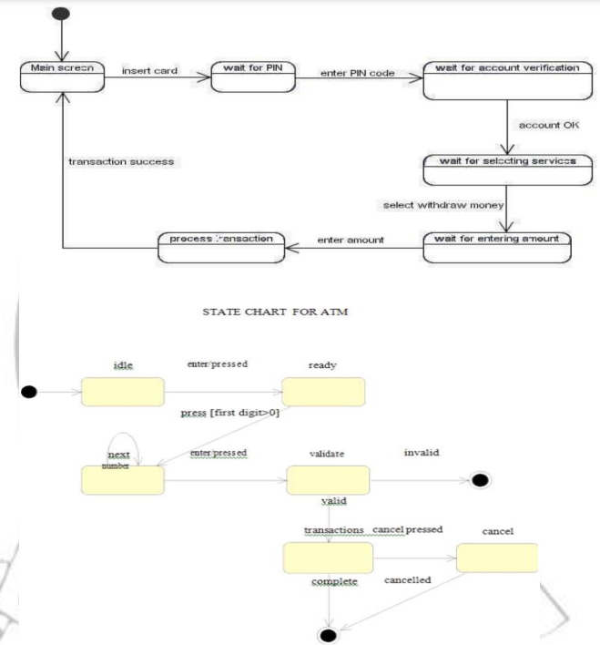

**Draw the Activity Diagram for the system**

Step1: First initial state is created.

Step2: After that it goes to the action state insert card.

Step3: Next it undergoes transition to the state enter pin

Step4: In this way it undergoes transitions to the various states.

Step5: Use forking and joining wherever necessary

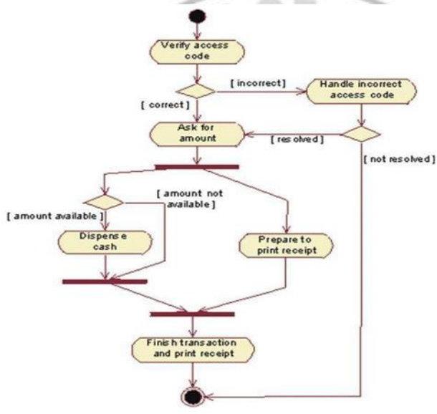

**Draw the Component Diagram for the system**

Step1: First user component is created.

Step2: ATM system package is created.

Step3: In it various components such as withdraw money, deposit money, check balance, transfer money etc. are created.

Step4: Association relationship is established between user and other components.

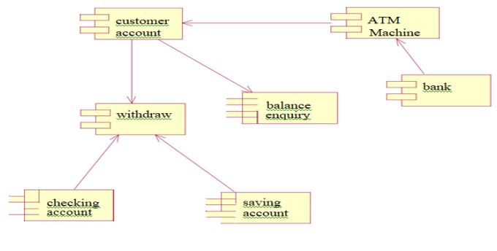

**Draw the deployment Diagram for the system**

